 | 
 | DAFTAR HADIR PERKULIAHAN GENAP 2020/2021
 |  | MATA KULIAH : METODOLOGI PENELITIAN MI/SD |  |  |  |  |  | SKS : 3 |  | SEMESTER / KELAS / RUANG : 4 / F / C.3.12
 |  | NO | NIM |  |  | NAMA MAHASISWA/I |  |  |  | 1 | 2 | 3 | 4 | 5 | 6 | 7 | 8 |  | 9 |  | 10 | 11 | 12 | 13 | 14 | 15 | 16
 |  | 1 | 1911240176 |  |  | FADHILA RAHMAWATI |  |  |  | M | M | M | M | M | M | M | M |  | M |  | M | M | M | M | M | M | M
 |  | 2 | 1911240177 |  |  | EMELDA KATESA |  |  |  | M | M | M | M | M | M | M | M |  | M |  | M | M | M | M | M | M | M
 |  | 3 | 1911240178 |  |  | AYU SARTIKA |  |  |  | M | M | M | M | M | M | M | M |  | M |  | M | M | M | M | M | M | M
 |  | 4 | 1911240179 |  |  | NOVELIA SUSANTI |  |  |  | M | M | M | M | M | M | M | M |  | M |  | M | M | M | M | M | M | M
 |  | 5 | 1911240180 |  |  | ASKINA JANATIN |  |  |  | M | M | M | M | M | M | M | M |  | M |  | M | M | M | M | M | M | M
 |  | 6 | 1911240181 |  |  | RAIHAN FADHILAH |  |  |  | M | M | M | M | M | M | M | M |  | M |  | M | M | M | M | M | M | M
 |  | 7 | 1911240182 |  |  | KLARA AYU MEIGINTA |  |  |  | M | M | M | M | M | M | M | M |  | M |  | M | M | M | M | M | M | M
 |  | 8 | 1911240183 |  |  | ANDO CANCERIO ARIGHI |  |  |  | M | M | M | M | M | M | M | M |  | M |  | M | M | M | M | M | M | M
 |  | 9 | 1911240184 |  |  | DWI ISTIQOMAH |  |  |  | M | M | M | M | M | M | M | M |  | M |  | M | M | M | M | M | M | M
 |  | 10 | 1911240185 |  |  | KHOFIFA URRAHMAH |  |  |  | M | M | M | M | M | M | M | M |  | M |  | M | M | M | M | M | M | M
 |  | 11 | 1911240186 |  |  | DIYOBA AZHAR FUADI |  |  |  | M | M | M | M | M | M | M | M |  | M |  | M | M | M | M | M | M | M
 |  | 12 | 1911240187 |  |  | NONI NOPITA |  |  |  | M | M | M | M | M | M | M | M |  | M |  | M | M | M | M | M | M | M
 |  | 13 | 1911240188 |  |  | NURFAZIRA |  |  |  | M | M | M | M | M | M | M | M |  | M |  | M | M | M | M | M | M | M
 |  | 14 | 1911240189 |  |  | SHIDQI RAHMATULLAH |  |  |  | M | M | M | M | M | M | M | M |  | M |  | M | M | M | M | M | M | M
 |  | 15 | 1911240190 |  |  | NOVITA WULANDARI |  |  |  | M | M | M | M | M | M | M | M |  | M |  | M | M | M | M | M | M | M
 |  | 16 | 1911240191 |  |  | SERLI LIA KUNTEZA |  |  |  | M | M | M | M | M | M | M | M |  | M |  | M | M | M | M | M | M | M
 |  | 17 | 1911240192 |  |  | PUPUT YUNITA |  |  |  | M | M | M | M | M | M | M | M |  | M |  | M | M | M | M | M | M | M
 |  | 18 | 1911240193 |  |  | KRISTA INDAH |  |  |  | M | M | M | M | M | M | M | M |  | M |  | M | M | M | M | M | M | M
 |  | 19 | 1911240194 |  |  | SYILA DWI ALTA MANDA |  |  |  | M | M | M | M | M | M | M | M |  | M |  | M | M | M | M | M | M | M
 |  | 20 | 1911240196 |  |  | SELVITA SARI |  |  |  | M | M | M | M | M | M | M | M |  | M |  | M | M | M | M | M | M | M
 |  | 21 | 1911240197 |  |  | WAHYU JULIAN |  |  |  | M | M | M | M | M | M | M | M |  | M |  | M | M | M | M | M | M | M
 |  | Waktu Dicetak : |  |  | Minggu, 25 Juli 2021 16:37:56
 |  | MATA KULIAH : METODOLOGI PENELITIAN MI/SD |  |  |  |  |  | SKS : 3 |  | SEMESTER / KELAS / RUANG : 4 / F / C.3.12
 |  | NO | NIM |  |  | NAMA MAHASISWA/I |  |  |  | 1 | 2 | 3 | 4 | 5 | 6 | 7 | 8 |  | 9 |  | 10 | 11 | 12 | 13 | 14 | 15 | 16
 |  | 22 | 1911240198 |  |  | LINA WIDIYA |  |  |  | M | M | M | M | M | M | M | M |  | M |  | M | M | M | M | M | M | M
 |  | 23 | 1911240199 |  |  | PIPIN MELINDA |  |  |  | M | M | M | M | M | M | M | M |  | M |  | M | M | M | M | M | M | M
 |  | 24 | 1911240200 |  |  | NADIYAH MAISYAROH |  |  |  | M | M | M | M | M | M | M | M |  | M |  | M | M | M | M | M | M | M
 |  | 25 | 1911240201 |  |  | RENTI HERLINA |  |  |  | M | M | M | M | M | M | M | M |  | M |  | M | M | M | M | M | M | M
 |  | 26 | 1911240202 |  |  | MUHAMMAD RIZKI APRILIANTO |  |  |  | M | M | M | M | M | M | M | M |  | M |  | M | M | M | M | M | M | M
 |  | 27 | 1911240203 |  |  | ULFA TUROHMI |  |  |  | M | M | M | M | M | M | M | M |  | M |  | M | M | M | M | M | M | M
 |  | 28 | 1911240204 |  |  | MONICA SHAPUTRA |  |  |  | M | M | M | M | M | M | M | M |  | M |  | M | M | M | M | M | M | M
 |  | 29 | 1911240205 |  |  | HAFIFA ZAHARA PUTRI |  |  |  | M | M | M | M | M | M | M | M |  | M |  | M | M | M | M | M | M | M
 |  | 30 | 1911240207 |  |  | SELLY MAYMUNAH |  |  |  | M | M | M | M | M | M | M | M |  | M |  | M | M | M | M | M | M | M
 |  | 31 | 1911240208 |  |  | DEVIA ANGGRAINI MUTMAINNAH |  |  |  | M | M | M | M | M | M | M | M |  | M |  | M | M | M | M | M | M | M
 |  | 32 | 1911240273 |  |  | RADEN PURBAYA |  |  |  | M | M | M | M | M | M | M | M |  | M |  | M | M | M | M | M | M | M
 |  | 33 | Dosen Utama |  |  | DRS. SUKARNO, M.PD |  |  |  | M | M | M | M | M | M | M | M |  | M |  | M | M | M | M | M | M | M
BENGKULU, 25 Juli 2021
Ka. Prodi
 |  |  |  |  |  |  |  |  |  |  |  |  |  |  |  |  |  |  |  |  | 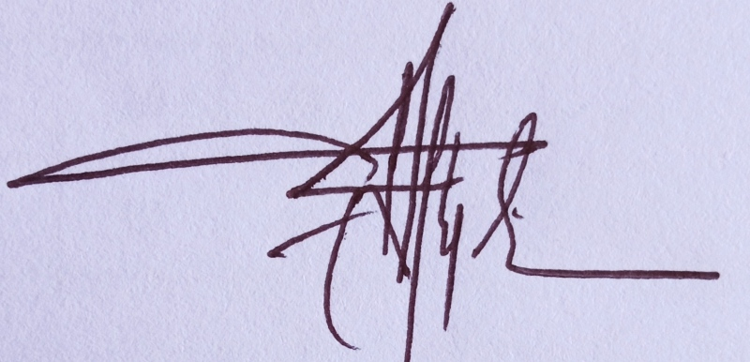
Dra. Aam Amaliyah, M.Pd
NIP : 196911222000032002
 |  | Waktu Dicetak : |  |  | Minggu, 25 Juli 2021 16:37:56

