Progress + Planning October-December 2024
1 | October | Write findings research in Enggano  Discussion with supervisors  Rethinking about the structure of dissertation
2 | November | Writing a draft of next chapter  Discussion with supervisors
3 | December | Rewriting the dissertation

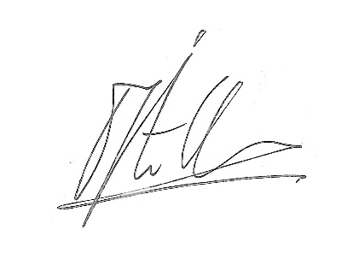
Prof. dr. Pieter ter Keurs
Leiden University
7 October

