ETNOMATEMATIKA PADA TRANSAKSI JUAL BELI
DI PASAR TRADISIONAL KOTA BENGKULU

Betti Dian Wahyuni ¹⁾ , Mela Aziza ²⁾
¹⁾ Fatmawati Sukarno State Islamic University, Bengkulu
betti.dian@mail.uinfasbengkulu.ac.id
²⁾University of Edinburgh, UK
emailpenulis_2@abc.ac.id

ABSTRAK
Penelitian ini bertujuan untuk mengidentifikasi dan mendeskripsikan etnomatematika pada aktivitas transaksi jual beli yang dilakukan pedagang di pasar tradisional Kota Bengkulu berdasarkan teori aktivitas fundamental matematis Bishop. Penelitian ini adalah penelitian eksploratif menggunakan pendekatan kualitatif. Subyek penelitian dipilih secara purposive meliputi pedagang beras, pedagang kacang-kacangan, pedagang telur, dan pedagang sayur. Instrumen penelitian berupa lembar observasi, dokumentasi, dan wawancara. Teknik analisis data melalui tiga tahap triangulasi, yaitu reduksi, penyajian, dan penarikan kesimpulan/verifikasi. Hasil penelitian ini menyimpulkan bahwa terdapat 6 aktivitas matematis diantaranya: (1) Counting pada penyebutan bilangan pokok menggunakan bahasa daerah (Bengkulu), sedangkan aktivitas menghitung dijumpai melibatkan operasi hitung yakni, penjumlahan, pengurangan, perkalian, dan pembagian; (2) Locating pada sistem zonasi dengan membagi pasar menjadi dua bagian, yakni pasar basah dan pasar kering yang dialokasikan secara terpisah; (3) Measuring pada sistem takar, pengukuran dan akurasi, mengurutkan, membandingkan dan mengestimasi berdasarkan kualitas, jenis, dan ukuran barang; (4) Designing pada pola-pola yang dimunculkan oleh pedagang saat mendesain/menata/menggelar barang dagangannya, dan bentuk ruang dagang; (5) Playing pada penerapan strategi penjualan; dan (6) Explaining pada aktivitas pedagang saat memberikan deskripsi/penjelasan tentang barang yang dijualnya.
Kata: Etnomatematika, Transaksi Jual Beli, Aktivitas Fundamental Matematis

ETHNOMATHEMATICS ON BUYING AND SELLING TRANSACTIONS IN THE TRADITIONAL MARKET IN BENGKULU CITY

ABSTRACT
This research aims to identify and describe ethnomathematics in buying and selling transaction activities carried out by traders in traditional markets in Bengkulu City based on Bishop's mathematical fundamental activity theory. This research is exploratory research using a qualitative approach. The research subjects were selected purposively, including rice, bean, egg, and vegetable traders. The research instruments include observation sheets, documentation, and interviews. The data analysis technique goes through three stages of triangulation: reduction, presentation, and drawing conclusions/verification. The results of this research concluded that there were six mathematical activities, including (1) Counting when pronouncing basic numbers using the local language (Bengkulu), while counting activities were found to involve arithmetic operations, namely, addition, subtraction, multiplication, and division; (2) Locating in the zoning system by dividing the market into two parts, namely the wet market and the dry market which are allocated separately; (3) Measuring the dosing system, measurement and accuracy, sorting, comparing and estimating based on the quality, type and size of goods; (4) Designing the patterns created by traders when designing/arranging/displaying their merchandise, and the shape of the trading room; (5) Playing in implementing sales strategies; and (6) Explaining the trader's activities when providing a description/explanation of the goods they sells.
Keywords : Etnomatematics, buying and selling tansaction, fundamental mathematical activitiess

PENDAHULUAN
Education is said to be a human effort to shape his personality by the values and culture prevailing in society (Sulasman & Gumilar, 2013). Culture includes the entire system of ideas that belong to humans through learning (Koentjaraningrat, 2015). So, there is a cultural process in every educational process; the two cannot be separated. Culture covers all aspects of human life, and education is a basic need for every individual in society. As we know that the meaning of culture itself is the result of human cultivation, this claims that education and culture are two elements that are very closely related. Culture dynamically adapts to the dynamics of society. Culture will develop massively along with the development of human cultivation. Human abilities can be developed through education (Kamid et al., 2021).
The Ministry of Education and Culture stated that teaching mathematics at the school level has a critical mission: to achieve national education goals, namely formal and material goals. Formal goals place more emphasis on reasoning and personality formation, and Material objectives place more emphasis on problem-solving abilities and mathematical implementation (Kemendikbud, 2011). In practice, mathematics learning in schools tends to be formal. Mathematics learning orientation only focuses on mathematical understanding and the ability to solve mathematical problems. Teachers do not involve students' mathematical ideas. Students' understanding is often obtained only through explanation or notification by the teacher, without mathematical exploration. This results in the emergence of cultural conflict, namely the difference between the mathematics children encounters daily and the mathematics they encounter at school (Nur et al., 2021) (Hiebert, J ; Carpenter, 1992).
In line with D'Ambrosio's statement, students think that studying mathematics is not helpful because mathematics is not needed in the field of work (career); in contrast to other subjects, the discussion of mathematics is too narrow, not interesting, and is considered less relevant. An understanding of mathematics that is not in-depth will create inappropriate attitudes and can even lead to negative attitudes toward mathematics(D’Ambrosio, 2020) (D’Ambrosio, 2006).
The scope of school mathematics material has been selected and adapted to students' cognitive stages to transfer its usefulness to students' daily lives quickly, as Freudhental stated that mathematics is a human activity and mathematics must be linked to human life (Freudenthal, 2002). Therefore, the implementation of mathematics learning must be able to be a link between mathematics at school and mathematics in students' real lives.
Supriadi (Supriadi, 2020) research on ethnomathematics, the aim is that the implementation of mathematics learning pays more attention to students' socio-cultural factors . The results of this research explain the fact that implementing learning with a socio-cultural approach can stimulate students to develop their intellectual, emotional, social, and political abilities through a cultural approach as an essential foundation that produces knowledge, understanding, skills, and attitudes.
In implementing mathematics learning, paying attention to students' informal knowledge is crucial. Therefore, before starting learning, it is necessary to extract informal information (initial knowledge) of students that they receive from the community, where problems of differences in cultural background arise (Gerdes, 1998) (Bryant, 1996). Mathematics is a form of culture embedded in all social life elements (A. Bishop, 1994). Culture influences individual behavior and plays a significant role in understanding abilities in mathematics (Bishop, 1991). So, a person's understanding of mathematics is also influenced by cultural factors. Basically, what a person does is based on what he sees and feels (A. J. Bishop, 1988).
The knowledge that connects culture and mathematics is called ethnomathematics. D’Ambrosio stated that ethnomathematics is how individuals from various cultural backgrounds use mathematics daily (D’Ambrosio, 2020). Meanwhile, Zhang (2010) states that ethnomathematics is a study that relates mathematics to a cultural background, including mathematical concepts that are generated and transferred and how mathematics blends into different cultural systems (Prediger, 2004).
Kuznetsova et al., explains that ethnomathematics is a variety of special methods usually used by certain groups or communities when carrying out mathematical activities such as grouping, sorting, calculating, and measuring (Kuznetsova et al., 2021) (Harris, 1987). According to D'Ambrosio ethnomathematics aims to recognize that in carrying out mathematical activities, different ways involve mathematical knowledge, which is developed from various levels of society. So, ethnomathematics is a representation that describes the culture of using mathematics and its implementation in society. Ethnomathematics is not new knowledge, but ethnomathematics has existed since the development of mathematics itself (D’Ambrosio, 2020).
Ethnomathematics is mathematics that grows and develops in the culture of a particular society. Culture covers all aspects of human life, including norms that apply to society, beliefs, customs, values, arts, knowledge, and habits that apply to society in a place or region.
Bengkulu Province is one of Indonesia's regions with various ethnic (cultural) characteristics. Various cultures developed in the people of Bengkulu Province, such as regional languages, traditional houses, and traditional food, as well as traditional ceremonies such as wedding ceremonies, baby shaving, death, religious ceremonies (Tabut), and all forms of activities -ethnomathematical activities that are practiced in other daily lives that apply in society, including buying and selling transaction activities that apply in society, which are of course different from other regions, so it would be interesting if a more in-depth investigation was carried out into this culture (Koto et al., 2021).
Traditional markets are centers of socio-economic activity. Traditional markets are a place of interaction between sellers or traders and buyers. The market is synonymous with buying and selling transaction activities carried out directly. There is also bargaining activity between sellers and buyers. This process involves mathematical activities, namely counting. Based on fundamental activity theory, states six basic mathematical activities: counting, locating, measuring, designing, playing, and explaining (A. Bishop, 1994). Then, the mathematical aspects contained therein are obtained from the fundamental activities obtained.
Buying and selling transaction activities carried out by the people of Bengkulu are also closely related to mathematics. Based on initial observations that researchers have made, researchers found several mathematical aspects of buying and selling transaction activities carried out by traders in traditional markets in the city of Bengkulu; these activities include counting, counting, and measuring. We often encounter this activity when shopping at traditional markets. In buying and selling transaction activities, several arithmetic operations are often found: addition, subtraction, multiplication, and division. Meanwhile, measurement involves measuring standard units and measuring non-standard units.
The results of other researchers' observations are that traders who sell in traditional markets in Bengkulu City, when interacting (carrying out transaction activities), usually use their native Bengkulu regional language. However, it is expected that they will use languages from other ethnic groups. Basically, the people of Bengkulu City come from various immigrant tribes (Koto et al., 2021). Most traders in traditional markets are not equipped with higher education. However, they can carry out the activity of calculating several transactions quickly without even using calculating/measuring tools. These mathematical activities are carried out daily and have a different way of calculating/measuring from what they usually learn while at school. It is something interesting to explore, study, and research.
The ethnomathematical activities carried out by these traders should be explored so that the public (especially students) can know and realize that their activities are related to mathematical concepts. It can also be used as a reference, especially for mathematics teachers, to implement ethnomathematics as a basis for learning so that mathematics learning is more realistic. Hopefully, it can provide students with knowledge and understanding (cognitive domain). The plus point is the achievement of understanding the values which are the essence of culture. It is also hoped that it can foster their feelings of love for local Bengkulu culture.

METODE PENELITIAN
This research is exploratory research using a qualitative approach. The implementation of this research observes ethnomathematics activities in buying and selling transaction activities carried out by traders in traditional markets, which occur naturally as is, and there is no manipulation of circumstances and conditions during the research implementation.
This research is exploratory research using a qualitative approach. The implementation of this research observes ethnomathematics activities in buying and selling transaction activities carried out by traders in traditional markets, which occur naturally as is, and there is no manipulation of circumstances and conditions during the research implementation. Research subjects were selected purposively, according to considerations from observation results, which showed unique ethnomathematics activities, with the subject selection criteria being the types of goods sold by the subjects involving local cultural objects, including object/material culture and non-object/non-material culture. So, the selected subjects were rice traders, nuts traders, egg traders, and vegetable traders. The research locations were three traditional markets in Bengkulu City: Pagar Dewa Main Market, Panorama Traditional Market, and Minggu Traditional Modern Market (PTM).
Data collection techniques include field notes (observations), documentation, and interviews. The data analysis technique goes through three stages of triangulation: reduction, presentation, and drawing conclusions/verification.

HASIL DAN PEMBAHASAN
Below, we will present an analysis of data from research on ethnomathematics activities on buying and selling transactions carried out by traders in traditional markets in Bengkulu City. Ethnomathematical activities that emerged were analyzed based on Bishop's (A. Bishop, 1994) fundamental mathematical activity theory, including counting, locating, measuring, designing, playing, and explaining. These activities can be explained as follows:
      - Counting
Counting activities are related to numbers that show 'how much' or 'the amount of something'. Coplay (2001), numbers are symbols which are objects consisting of numbers. In general, most of the people of Bengkulu City do not say basic numbers using Indonesian but instead use Bengkulu or the language they usually use in everyday conversations. The basic numbers in Bengkulu include: sikok (one), duo (two), tigo (three), empek (four), limo (five), enam (six), tujuh (seven), delapan (eight), sembilan (nine) , sepuluh (ten). The main number, if it shows the classification, will change shape. The word sikok 'one' will change to se. The number 'teen' becomes bele, such as sebele (eleven), duobele (twelve), tigobele (thirteen), empekbele (fourteen) limobele (fifteen), etc (Sulistio & Qohar, 2020) .
Traders in the traditional markets of Bengkulu City tend to make the number values smaller; they use thousands as the unit, and this is done to make calculations easier. This counting activity is seen when traders count the number of goods purchased by consumers, calculate the selling price, and calculate the amount of change.
In the activity of determining the selling price of goods, traders consisting of subjects S1 (rice trader), S2 (nut trader), S3 (egg trader), and S4 (vegetable trader) stated that the selling price was determined by rounding to five hundred or thousands. , to make it easier to count and to anticipate change if there are no coins. Counting activities are also found when traders count the goods consumers purchase. So that there are many shopping items, the prices are calculated, and nothing is missed; the method used by research subjects S1, S2, S3, and S4 is when they put the goods purchased by consumers into plastic bags (Bengkulu people call them 'asoi') in a plastic bag—one by one.
Meanwhile, counting activities are often found in buying and selling transactions between traders and buyers, namely calculating total consumer purchases, the amount of change, and sales profits. In the activities above, there are mathematical concepts and the use of arithmetic operations used by traders in the traditional market of Bengkulu City during buying and selling transactions, including:
            - Addition
Based on observations and interviews, there are strategies for calculating addition operations used by traders in traditional markets in Bengkulu City, including:
- Ignore the zeros, which act as thousands first;
- Add using the Count on Strategy, namely starting with a larger number and 'counting on' other additions to get the result of the addition. For example, if the number sentence is 4+3, then the trader will identify 4 as the larger number and count the other three numbers again “4...5, 6, 7”. The answer to the addition is 7. In this case, it appears that the trader can 'store' a number in his mind and then add it up. The Count on Strategy carried out by traders is depicted in the following chart: 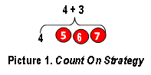
- Add the values of tens of thousands with tens of thousands, then add the values of thousands with thousands; after that, the results of the two additions are added again. If one of the numbers contains five hundred, then the five hundred are ignored and added at the end of the calculation. However, if both contain five hundred, then the value of five hundred is added to the five hundred, then added to the sum of thousands, and then added to the value of tens of thousands. This method is called the adjusting strategy. This strategy can be used simultaneously with all estimation strategies and all types of operations or is called adjusting with front-end estimation strategy (Amirulmukminin & Aprianti, 2019) (Hidayah & Sholihah, 2023). In a case example, the adjusting with front-end estimation strategy can be illustrated in the following picture:
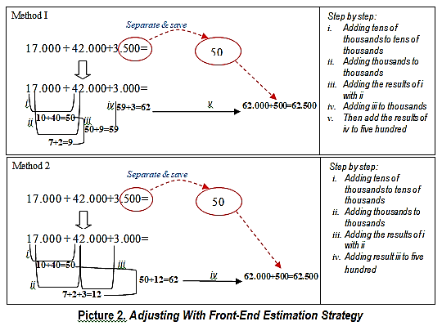
- Rounding to the nearest tens. For example, the numbers 35, 36, 37, 38, and 39 are numbers close to 40. This technique is called Bridging through ten (addition) (Thompson, 1999) (Barrera-Mora et al., 2018); this value can be calculated by adding the numbers rounded to the nearest tens with the remaining number subtracted from the number needed to round to the tens. If one of the numbers contains five hundred, then the value of the five hundred is ignored first and added at the end of the calculation. For numbers containing five hundred, the result of adding the two five hundred can be added last; after that, the addition can be added to the result of the addition with a rounding number previously. In a case example, the Bridging through ten (addition) strategy is illustrated in the following figure:
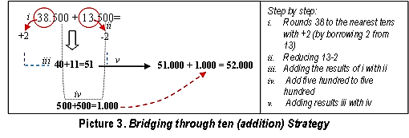
Based on the data above, it can be concluded that the addition algorithm used by traders in buying and selling transaction activities in the traditional markets of Bengkulu City uses several strategies, including count-on strategy, adjusting with front-end estimation strategy, and bridging through ten (addition) strategy, where in every calculation process you always ignore the three zeros at the end which act as thousands. Traders do this to make it easier to complete calculations because, in trading, most traders often do not use calculators, but this can be done quickly by traders. However, for convenience and buyers' confidence in the accuracy of calculations, traders also often use calculators, especially if the buyers' (consumers') purchases have a wide variety of goods with a reasonably large accumulated purchase amount.
            - Subtraction
Subtraction calculation operation is visible when merchant activities calculate refunds for consumer purchases. This was found in the activity of one of the subjects (S3.1) when making a return, with the following case: a consumer shopping for goods worth IDR 24,000.00 was paid with money worth IDR 50,000.00. The subject's way of calculating returns is by completing the subtraction first in tens and above (complementing upwards), known as counting up from (complementary addition) (Thompson, 1999) (Barrera-Mora et al., 2018), namely starting with a smaller number (in subtraction) and counting up. In the sense of completing it upwards to reach the money spent. In one case, the counting-up strategy is illustrated in the following figure:
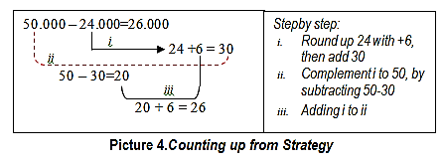
Activities involving other subtraction calculation operations appear when traders determine profits. Profit is the total income minus the total costs incurred.
            - Multiplication
Calculations using multiplication operations appear when buyers carry out buying and selling transactions with traders, namely when traders calculate the volume (amount) of goods purchased by the buyer multiplied by the selling price of the goods. Just like addition or subtraction operations, traders always ignore the three 0s that act as thousands in every calculation process. Some traders use a strategy of rounding out numbers. The multiplication strategy these traders use utilizes friendly multipliers (Mabbott & Bisanz, 2003), such as multiplying multiples of 10 to make calculations easier. Next, multiply the numbers containing tens of thousands and thousands one by one by the multiplier, then add the results of the two together. This method also applies to numbers containing five hundreds, namely by multiplying the hundreds by a multiplier and adding them to the results of the previous addition.
In the case of a buyer who wants to buy 3 cups of rice for a cup of rice at a price of IDR 18,000.00, the trader's method is to ignore the zeros for thousands, then multiply the tens value 10x3=30, and multiply the unit value 8x3=24. Next, add up the two multiplication results, namely 30+24=54. So, the amount of money that the buyer must pay is IDR 54,000.00.
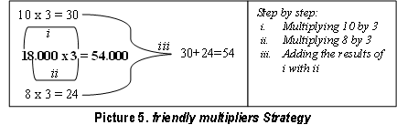
- Division
Calculations using division operations appear when traders offer goods in multiple packages (parties/wholesale), where for purchases of this type of goods, there has been a price agreement between the trader and the buyer. In one case of selling tomatoes, the price per kilogram was IDR 10,000.00, and the price per two kilograms was sold for IDR 18,000.00. If the buyer wants to buy half a kilogram, the calculation method is to divide 10:2=5, meaning half a kilogram of tomatoes costs IDR 5,000.00. However, if the buyer wants to buy a quarter kilogram package, then 10:4=2.5 means the price of one-fourth of a kilogram of tomatoes costs IDR 2,500.00. However, to make calculations easier and anticipate the unavailability of coins for returns, traders often round up the price of one-fourth kilogram of tomatoes from IDR 2,500.00 to IDR 3,000.00.
At first glance, the counting operations carried out by traders in the traditional markets of Bengkulu City seem simple, but these steps involve complex counting concepts and strategies. Traders can easily carry out calculations without a calculating tool/calculator because it is based on their habits in daily mathematical activities. The calculation strategy or algorithm they use is a combination of systematic mental calculation strategies.
The calculation methods/algorithms traders use are different from those taught in schools. This can be used as an alternative idea to be implemented in mathematics learning, especially number-counting operations. The concepts and calculation strategies traders use are essential for students to know and understand at school, aiming to improve students' numeracy abilities and skills as well as sharpen students' mental math.
Mental math is a group of skills that allows students to do mathematics "in their heads" without using a pencil and paper or a calculator (Hodnett). Mental math is helpful in school and everyday life. Mental math can help students understand mathematical concepts better and get answers more quickly.
      - Locating
Locating activities can be seen in zoning, namely the placement of traders' selling locations, which are classified based on the type of commodity/goods being traded. Traditional markets are divided into wet markets (pasar basah )and dry markets (pasar kering), which are allocated separately. In the wet market, there are goods sold by traders, such as meat, fish, fruit, vegetables, and spices, and home-cooked food stalls. Meanwhile, dry markets usually sell dry goods, such as household items, dry spices, clothes, and homemade snacks.

      - Measuring
One of the measuring activities can be seen in a dosing system. Bengkulu people still have a strong tradition regarding the measuring system, which differs from other regions. Based on the results of observations in the field, there is a measuring system in buying and selling transaction activities carried out by traders in the traditional markets of Bengkulu City, where several types of goods are measured/measured in a measuring system using non-standard measuring tools. The measuring system in this research, which traders use in traditional markets in Bengkulu City, is used for types of merchandise, namely rice, beans, eggs, and vegetables.

      - Rice
Rice traders usually sell rice obtained from various regions in Bengkulu Province, even from outside Bengkulu, such as from Lampung, Seghinim, and others. In rice buying and selling activities, rice traders tend to sell in retail form, besides also selling wholesale. The retail measuring system uses a tube-shaped device called a cupak with a volume of 2 liters. Cupak is a unit that indicates the amount or weight of rice used by the people of Bengkulu City to measure rice. A cupak = ± 1.6 kg (one kilo six ounces).
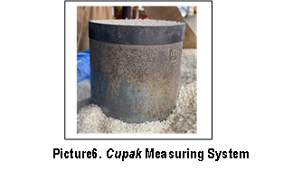
      - Red Beans, Green Beans, and Peanuts
Traders who sell various types of nuts usually sell their goods retail in 'Canting' quantities. This canting measuring system uses a tube-shaped tool, usually made from used milk cans or cigarette cans.Traders use this canting to measure items such as peanuts, green beans, and red beans. Apart from that, canting is also used to measure other goods such as leuca, black sticky rice, split gills mushrooms, and leucanea.

The following is an illustration of the measuring system in canting:
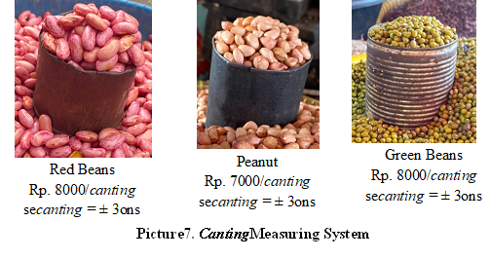
      - Eggs
In the Bengkulu traditional market, egg traders sell eggs in units. Chicken eggs are usually sold in quantities/packaging called karpet. The size of a karpet contains 30 eggs, and a half-carpet package contains 15 eggs. However, depending on buyer demand, it does not rule out the possibility of being sold per item. Alternatively, even traders usually sell small-sized eggs at a selling price of IDR 5,000.00 per 3 eggs; medium sized eggs are sold for IDR 2,000.00, while large-sized eggs are sold for IDR 5,000.00 per 2 eggs. Measuring activities are also carried out when traders determine the price per egg, namely by making comparisons and estimates depending on the appearance and size of each egg. They are usually sorted into three sizes, namely large, medium, and small.
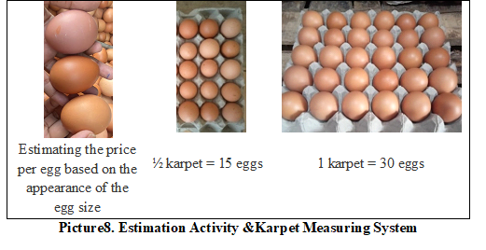
      - Vegetables
The selling price of types of vegetables is determined using a system of weighing, portion/package, and kebe' (kebat/tie). The portion/wrap packaging system combines several types of vegetables with the ideal quantity for a portion of food. Traders more often do this because most buyers/consumers prefer to buy vegetables in economical and inexpensive packaging so that it is more attractive for consumers to buy. Examples of vegetables in portion/wrap packages include vegetable soup and tamarind vegetables. One portion/pack of tamarind vegetables or raw vegetable soup is sold for an average IDR 5,000.00.
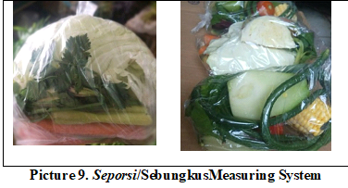
Meanwhile, green vegetables such as kale, spinach, mustard greens, sweet potato shoots and lettuce are usually sold in kebe' (kebat/tie) packaging. For mustard greens, each bundle in the pile ranges from 9-10 trees, while kale, spinach, sweet potato shoots, and lettuce range from 40-50 trees, with an average selling price for green vegetables of IDR. 3000.00.
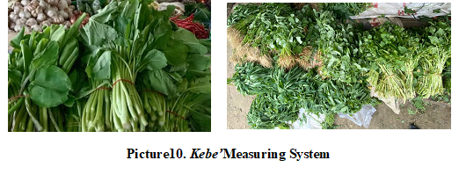
Apart from the packaging above, other types of vegetables are measured/measured using scales in ounces or kilograms, in this case requiring precision/accuracy in measuring the scales (accuracy), so that traders gain trust and satisfaction from consumers.
Another measuring activity is related to money, namely determining the amount of market levies traders must pay. Retribution payments can be made over some time, namely monthly or daily. Traders who own permanent kiosks usually pay monthly, namely IDR 80,000 per month, but it is not uncommon for traders to pay daily. Based on information from traders and market managers, the same rate applies for payment of market levies by traders, both for traders selling in kiosks and traders selling in stalls/overhangs, namely IDR 3,000 per day.

      - Designing
Designing activities in buying and selling transactions carried out by traders in the traditional markets of Bengkulu City can be seen in the patterns created by traders when designing/arranging/displaying their merchandise. How to design/arrange merchandise is a technique where traders prepare goods for display to attract consumers to buy. Based on the results of interviews with subject S1 (rice traders), it is known that the way to arrange merchandise (rice) before starting to sell is to pay attention to the type and quality of rice. Each type of rice is separated into a wooden container/box and arranged to start from high-quality rice to low-quality or vice versa. Each is given a price tag to provide accessible service to consumers (buyers).
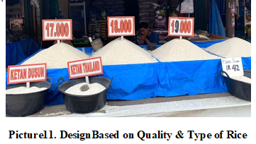
Meanwhile, S2 subjects, traders who sell various nuts, have a way of designing/arranging merchandise, namely simply separating the goods based on the type and separating them into containers or mats.
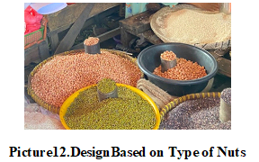
Meanwhile, S3 (egg traders) have a way of presenting/displaying their merchandise by sorting the eggs first and grouping them based on size (large-medium-small), and then each one is arranged in a container and labeled. Price (by order). As shown in the following image:
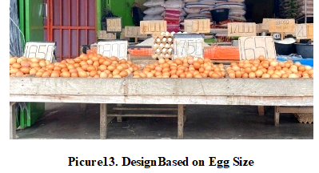
Likewise, S4 (vegetable trader) presents his merchandise by grouping goods according to type.
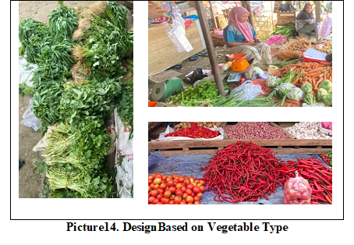
Designing activities are also visible in the form of the trading room. Some are in the form of kiosks and stalls. A kiosk is a trading space in the form of a fixed building and is separated by a dividing wall equipped with a door. Meanwhile, a stall is a trading space that is permanent and open, with a roof without walls, whose use is divided into plots.

      - Playing
Playing activity occurs during the bargaining process between traders and buyers to reach an agreement on price. Based on the interviews with subjects S1, S2, S3, and S4, it is clear that the traders have given the right price, meaning that the traders only take a little profit, considering that the goods sold are basic household necessities. However, many buyers are still trying to haggle over the price. Goods so that you can get a discount to make them cheaper, by way of persuasion or the lure of "being a bestseller" or "will become a customer", but this has become a culture or habit that is accepted by the public, both from the side of traders and buyers.
Apart from that, playing activities can also be seen in the use of sales strategies by traders, such as providing polite and pleasant service, providing a "slight advantage" in measurements (scales, etc.), providing lower prices than competitors, and providing discounts if buyers buy goods in large quantities/parties. Apart from the above, subject S1 (rice seller) added a strategy: providing a guarantee for returning/exchanging goods if the rice purchased does not match what the seller described.

      - Explaining
In traditional markets, buyers are usually served directly by sellers/traders. Explaining activities appear when traders sell goods to buyers. The trader will provide a description/explanation of the goods he sells, relating to the price of the goods, quality/advantages of the goods, size/quantity of the goods, type of goods, characteristics of the goods, similarities/differences between type A and type B goods, as well as showing testimonials from buyers who have ever purchased (for example, there happens to be a customer who has previously purchased).
Based on the results of observations on subject S1, a buyer asked which type of rice produces fragrant and fluffier rice, then the seller explained in detail the quality, grain size and characteristics of each type of rice. Traders recommend feeling the texture of the rice, if the rice feels 'pera' then the rice, when cooked, will produce pera textured rice (a slightly hard rice texture). Meanwhile, fluffier rice itself usually has a grain size that looks shorter and fatter.
The mathematical activities found in this study may be influenced by local customs, beliefs, and traditions in Bengkulu City; for example, the methods used by traders when measuring can vary based on the commonly used measurement culture in Bengkulu. These findings indicate a connection between culture and mathematics that occurs in the market. Research conducted in markets that have different cultures are likely to find different ethnomathematics activities. It can be seen from previous studies that have explored the mathematical and cultural aspects of buying and selling transactions in traditional markets like Febriyanty and Nasution studied ethnomathematics at a Javanese market (Febriyanty & Nasution, 2022) and Nurjanah, Mardia, and Turmudi studied a trading of Minangkabau tribe (Nurjanah et al., 2021). Therefore, further research will be very useful to increase the finding of mathematical activities in societies’ daily activities.
The understanding of ethnomathematics on buying and selling transaction could inform educational practices, potentially integrating these real-life mathematical applications into the teaching curriculum to make mathematics more relevant to students. As a result, the process to encourage students not only learn about mathematical concepts but also cultures will eliminate the distinction between mathematics and culture (François, 2010) (Suherman & Vidákovich, 2024). Including Ethnomathematics into the curriculum can help restore cultural dignity and provide the necessary tools to construct a civilization that rejects inequity, arrogance, and prejudice (D’Ambrosio, 2006).

CONCLUSION
The results of this research concluded that there were six mathematical activities, including: (1) Counting when pronouncing basic numbers using the local language (Bengkulu), while counting activities were found to involve arithmetic operations, namely, addition, subtraction, multiplication, and division; (2) Locating in the zoning system by dividing the market into two parts, namely the wet market and the dry market which are allocated separately; (3) Measuring the dosing system, measurement and accuracy, sorting, comparing and estimating based on the quality, type and size of goods; (4) Designing the patterns created by traders when designing/arranging/displaying their merchandise, and the shape of the trading room; (5) Playing in implementing sales strategies; and (6) Explaining the trader's activities when providing a description/explanation of the goods he sells

DAFTAR PUSTAKA

Amirul mukminin, A., & Aprianti, K. (2019). Pengembangan Perangkat Pembelajaran Untuk Meningkatkan Kemampuan Estimasi Matematika Ekonomi Melalui Permainan Tradisional Mpa’a Amba. Kreano, Jurnal Matematika Kreatif-Inovatif, 10(2). https://doi.org/10.15294/kreano.v10i2.20642
Barrera-Mora, F., Reyes-Rodríguez, A., & Mendoza-Hernández, J. G. (2018). Mental calculation strategies for addition and subtraction developed by middle school students [Estrategias de cálculo mental para sumas y restas desarrolladas por estudiantes de secundaria]. Educacion Matematica, 30(3).
Bishop, A. (1994). Cultural Conflicts in Mathematics Education: Developing a Research Agenda. Learning of Mathematics, 14(2).
Bishop, A. J. (1988). The Interactions of Mathematics Education with Culture. Cultural Dynamics, 1(2). https://doi.org/10.1177/092137408800100202
D’Ambrosio, U. (2006). Copenhagen, Preface : Ethnomathematics And Mathematics Education. International Congress of Mathematics Education. University of Pisa.
D’Ambrosio, U. (2020). In My Opinion: What Is Ethnomathematics, and How Can It Help Children in Schools? Teaching Children Mathematics, 7(6). https://doi.org/10.5951/tcm.7.6.0308
Febriyanty, L., & Nasution, A. S. (2022). Ethnomathematics at javanese traditional food market. Jurnal Pijar Mipa, 17(2). https://doi.org/10.29303/jpm.v17i2.3397
François, K. (2010). The Role of Ethnomathematics Within Mathematics Education. Proceedings of Cerme, December.
Freudenthal, H. (2002). Revisiting Mathematics Education: China Lectures. Springer.
Gerdes, P. (1998). On Culture and Mathematics Teacher Education. Journal of Mathematics Teacher Education, 1(1).
Harris, M. (1987). An Example of Traditional Women’s Work as a Mathematics Resource. For the Learning of Mathematics, 7(3).
Hidayah, R. W., & Sholihah, U. (2023). Analisis Kemampuan Number Sense Siswa Berdasarkan Kemampuan Matematika pada Materi Bilangan. JNPM (Jurnal Nasional Pendidikan Matematika), 7(1). https://doi.org/10.33603/jnpm.v7i1.7417
Hiebert, J ; Carpenter, T. (1992). Learning with understading. In D.G. Grouws (Ed), Handbook of Research on Mathematics Reaching and Learning. Macmillan.
Kamid, Rohati, Kurniawan, D. A., Perdana, R., Chen, D., & Wulandari, M. (2021). Impact of the Integration of Ethno-mathematics with TPACK framework as a problem-based learning (PBL) model. Eurasian Journal of Educational Research, 2021(96). https://doi.org/10.14689/ejer.2021.96.14
Kemendikbud. (2011). Peran Lembaga Adat.
Koentjaraningrat. (2015). Pengantar Ilmu Antropologi. Rineka Cipta.
Koto, E. A., Samudra, A. A., Zainal, V. R., Sumrahadi, A., Hakim, A., Hariyadi, A. R., & Subagja, I. K. (2021). Relationship of work Motivation and participative Leadership with Functional Employment Behavior of Education and Culture of Bengkulu Province, Indonesia. International Journal of Business, 5(9). https://doi.org/10.33642/ijbass.v5n9p1
Kuznetsova, E., Zhbanova, N., & Golovaneva, F. (2021). The Role Of Mathematics And Its Teaching For Sustainable Development. https://doi.org/10.15405/epsbs.2021.09.02.24
Nur, A. S., Marlissa, I., Kamariah, K., Palobo, M., & Ramadhani, W. P. (2021). Mathematics education research in Indonesia: A scoping review. Beta: Jurnal Tadris Matematika, 14(2). https://doi.org/10.20414/betajtm.v14i2.464
Nurjanah, N., Mardia, I., & Turmudi, T. (2021). Ethnomathematics study of Minangkabau tribe: formulation of mathematical representation in the Marosok traditional trading. Ethnography and Education, 16(4). https://doi.org/10.1080/17457823.2021.1952636
Prediger, S. (2004). Intercultural perspectives on mathematics learning - Developing a theoretical framework. International Journal of Science and Mathematics Education, 2(3). https://doi.org/10.1007/s10763-004-2685-7
Suherman, S., & Vidákovich, T. (2024). MathematicalCreative Thinking-Ethnomathematics based Test: Role of Attitude toward Mathematics, Creative Style, Ethnic Identity, and Parents’ Educational Level. Revista de Educación a Distancia, 24(77). https://doi.org/10.6018/red.581221
Sulasman, & Gumilar, S. (2013). Teori-teori Kebudayaan: Dari Teori Hingga Aplikasi. Pustaka Setia.
Sulistio, W., & Qohar, A. (2020). Development of Instructional Media “Game Math Comic Story” Based Android on Number. Journal of Education Research and Evaluation, 4(2). https://doi.org/10.23887/jere.v4i2.22370
Supriadi, S. (2020). Pre-service elementary teachers: Analysis of the disposition of mathematical modeling in ethno mathematics learning. Elementary Education Online, 19(3). https://doi.org/10.17051/ilkonline.2020.730747
Thompson, I. (1999). Mental calculation strategies for addition and subtraction: part 1. Mathematics in School, 28(5).

