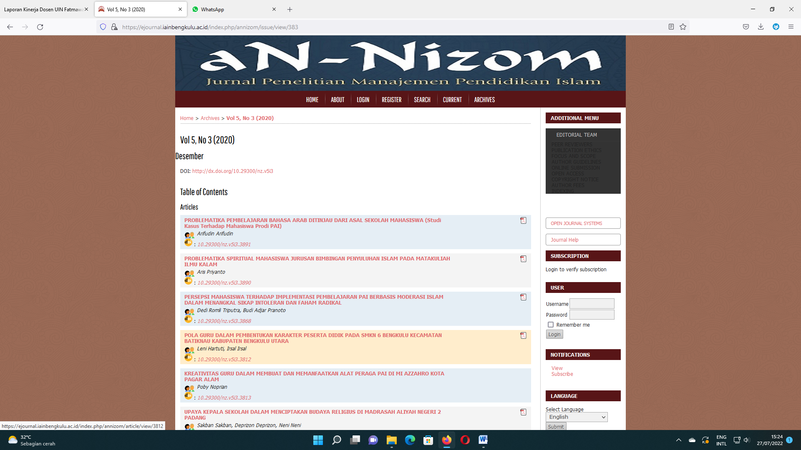

https://ejournal.iainbengkulu.ac.id/index.php/annizom/issue/view/383

