Bullying Research Trends In Counseling:
A Bibliometric Analysis

Hermi Pasmawati*, Badeni ^{2,} I wayan Dharmayana ³,Vira Afriyati ⁴
*Author Corespondence  Hermi Pasmawati  UIN Fatmawati Sukarno, Bengkulu  Jln. Raden Fatah, Pagar Dewa Bengkulu  Indonesia  Email: hermipasmawati@mail.uinfasbengkulu.ac.id  Badeni  Universitas Bengkulu, Bengkulu  Jln. W.R Supratman,Kandang Limun, Bengkulu  Indonesia  Email: badeni@unib.ac.id  I Wayan Darmayana  Universitas Bengkulu, Bengkulu  Jln. W.R Supratman,Kandang Limun, Bengkulu  Indonesia  Email: dharmayana@unib.ac.id  Badeni  Universitas Bengkulu, Bengkulu  Jln. W.R Supratman,Kandang Limun, Bengkulu  Indonesia  Email: Vira@konselor.org  Page  X-X | ABSTRACT  Abstract This study conducted a bibliometric analysis of bullying research trends in counseling. It used the VOSviewer analysis tool and data from the Scopus database. The study included an analysis of 174 articles published between 2014 and 2024. Bibliometric methods were used to collect and analyze the data. The goal was to identify patterns and trends in bullying research, including the most frequently discussed topics, the most influential journals, and the most prolific authors and institutions. With the help of VOSviewer, the data was analyzed to map relationships between keywords, collaborations between researchers, and the geographic distribution of research. This analysis provides in-depth insight into the direction of bullying research in counseling. They are intended to guide researchers and practitioners in developing further studies in this area.  Keywords: bullying, counseling, bibliometric analysis, developing bullying research

INTRODUCTION [ Arial 10, bold]
Bullying has long been recognized as a significant social problem that has a profound and lasting impact on the mental health and well-being of individuals ((Pradana, 2024; Swit et al., 2023; Xu et al., 2024). In counseling, understanding and addressing the impact of bullying is very important. Counselors often work with victims, perpetrators, and witnesses of bullying (Addy et al., 2021; Aishwarya Gowda et al., 2022; Smith, 2014)(Addy et al., 2021). Over the past decade, there has been an increase in the number of studies examining various aspects of bullying, including causes, consequences, and interventions. This research is critical to the development of effective counseling strategies that can help individuals cope with and overcome the negative effects of bullying (Li et al., 2022; Marcos et al., 2024; Sainz et al., 2023; Thornton et al., 2024) .
Although the volume of research on bullying continues to increase, there is still a need for systematic review and analysis of trends in the field, particularly in the context of counseling. Bibliometric analysis, which is the statistical evaluation of publications, is an effective method for the identification of research trends, major themes, and influential works in a particular field (Sainz et al., 2023; Van Raan, 2014). Through the use of bibliometric methods, researchers can gain insight into the development of a research area over time, identify gaps in the literature, and highlight new topics that need further research (Donthu et al., 2021; Efianingrum et al., 2021; Merrin et al., 2024; Van Eck & Waltman, 2010).
This study aims to conduct a bibliometric analysis of bullying research in counseling using data from the Scopus database. This analysis includes publications from 2014 to 2024, totaling 174 articles. By utilizing VOS viewer, a powerful tool for visualizing bibliometric networks, the study aims to map key trends in bullying research, including the most frequently discussed topics, the most influential journals and authors, and collaboration patterns between researchers. The results of this study are expected to provide valuable insights into the development of bullying research in the context of counseling and become a source of reference for researchers and practitioners who want to explore new studies relevant to this study.

METHODOLOGY
This study uses a bibliometric approach to analyze bullying research trends in the context of counseling. Bibliometrics is a method used to evaluate and map scientific literature through statistical analysis of publications (Ratnasari, A., & Dwisusanto, 2024; Van Eck & Waltman, 2010; Zakiyyah et al., 2022; Zupic & Čater, 2015) The data used in this study comes from a reliable source, namely the Scopus database. Scopus is one of the most respected data sources in the world of research, spanning a wide range of disciplines and hosting leading scientific publications (Burnham, 2006)
Data was collected by conducting an online literature search in the Scopus database using the keywords bullying and counseling. This search is limited to articles published between 2014 and 2024, to get an overview of research trends over the past decade. 174 articles were identified and used as samples in this analysis. The article selection process is carefully carried out to ensure the relevance and quality of the data used (Aria & Cuccurullo, 2017; Zakiyyah et al., 2022)
Once the data is collected, the analysis is carried out using the VOS viewer software. VOS viewer is a commonly used tool in bibliometric analysis to visualize the networks of keywords, authors, journals, and institutions that most often appear in the literature (Muhammad & Triansyah, 2023; Van Eck & Waltman, 2010). This tool allows researchers to identify research clusters, relationships between topics, and emerging trends in the literature related to bullying and counseling.
In this analysis, the most frequently used keywords, the most productive authors, and the most influential journals and institutions are identified. In addition, the pattern of collaboration between researchers was also analyzed to provide an overview of the dynamics of collaboration in this field of research (Donthu et al., 2021; Muhammad & Triansyah, 2023). This analysis produces a visual map that helps understand the development of bullying research in counseling over the past decade.
To ensure the validity and reliability of the analysis results, all steps in the data collection and analysis process are carefully carried out by the procedures accepted in the bibliometric literature (Zupic & Čater, 2015) The use of Scopus as a data source also increases the reliability of findings, given the scope and quality of the data available in this database.

RESULT AND DISCUSSION
Visualization of topic areas using VOSviewer
The minimum number of terms in the use of VOS viewer is set at 2 terms. After analyzing with VOSviewer, there are 4 clusters (red, green, blue, and yellow) that show the relationship between one topic and another. VOS viewer can display bibliometric mapping in three different visualizations, such as network visualization (Figure 1) Network Visualization, (Figure 2) Overlay Visualization, and (Figure 3) Density Visualization. Keywords are labeled with colored circles. Circle size is a position that correlates effectively through the appearance of keywords in the title and abstract.
Network Visualization describes the relationships and interactions between the various components in a dataset. By mapping these connections, Network Visualization helps identify key patterns and structures, revealing how different elements are interrelated. This visualization is essential for understanding the overall framework and dynamics of the data, as well as providing insight into the network configuration and centrality of various nodes.
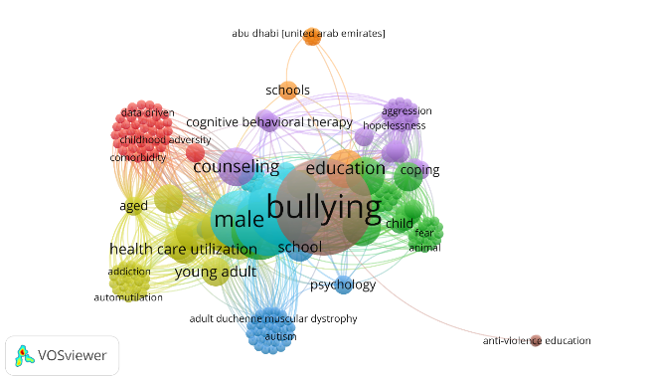

Figure 1. Visualization of topic areas using VOSviewer network visualization
Network Visualization shows clusters in each topic field being researched you can see keywords that are in the same cluster. Per-cluster data is shown in the following table:
Tabel 1.
Cluster results of bibliometric analysis
Cluster | Color | Item | Total
1 | Red | Cluster 1 | 43
2 | Green | Cluster 2 | 38
3 | Blue | Cluster 3 | 33
4 | Yellow | Cluster 4 | 33
5 | Purple | Cluster 5 | 29
6 | Light Blue | Cluster 6 | 20
7 | Orange | Cluster 7 | 12
8 | Brown | Cluster 8 | 5
The figure and table above provide information that the dominant research is in cluster 1 which is depicted by the color Red, namely; The bullying study with driven, childhood adversity and comorbidity data is 44 article documents. Meanwhile, the cluster is shown at least by the Brown color, which is related to bullying and anti-violence education studies. A total of 5 article documents.
Overlay visualizations combine multiple layers of data to show how various variables intersect and affect each other. This technique allows for a comprehensive view of how various factors interact in a dataset. By visualizing these overlaps, overlay visualization facilitates the identification of complex relationships and potential correlations that may not be apparent when examining data layers separately.
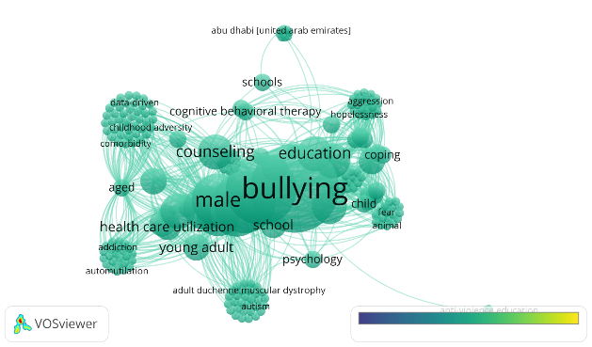
Figure 2. Visualization of topic areas using VOSviewer Overlay visualization
Furthermore, figure 2 shows the research trend from year to year which means that the yellow color is the most recent research trend, the older the color, the longer the research year is carried out. Based on the data visualization in Figure 2 above, it can be seen that bullying research is still very trendy and continues to grow or is still an interesting research trend that continues to be studied by researchers as seen from the colors displayed.
Density Visualization. The density visualization in Figure 3 highlights the areas with high concentrations in the dataset. This image uses color gradations or shadows to represent the density of data points in different regions. This visualization is particularly useful for locating clusters or hotspots, providing insight into where a particular phenomenon is most or most significant. By focusing on data density, Figure 3 helps identify trends and patterns related to data concentration.

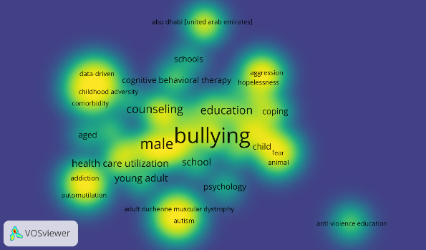
Figure 3. Visualization of topic areas using VOS viewer density visualization
The visualization of the topic area shows the depth and breadth of the research which means that the more intense the color appears, the more the number of research, and vice versa. The yellow region indicates the latest research trends, while the color intensity increases with the number of years of study. Figure 3 provides information that the study of bullying related to Counseling, Education, male, childhood adversity, addiction, and Bullying intervention with education is still very high in the interest of researchers in this theme. There are four techniques of bullying interventions identified, namely; counseling aggression hopelessness, cognitive behavior therapy dan anti violence education.
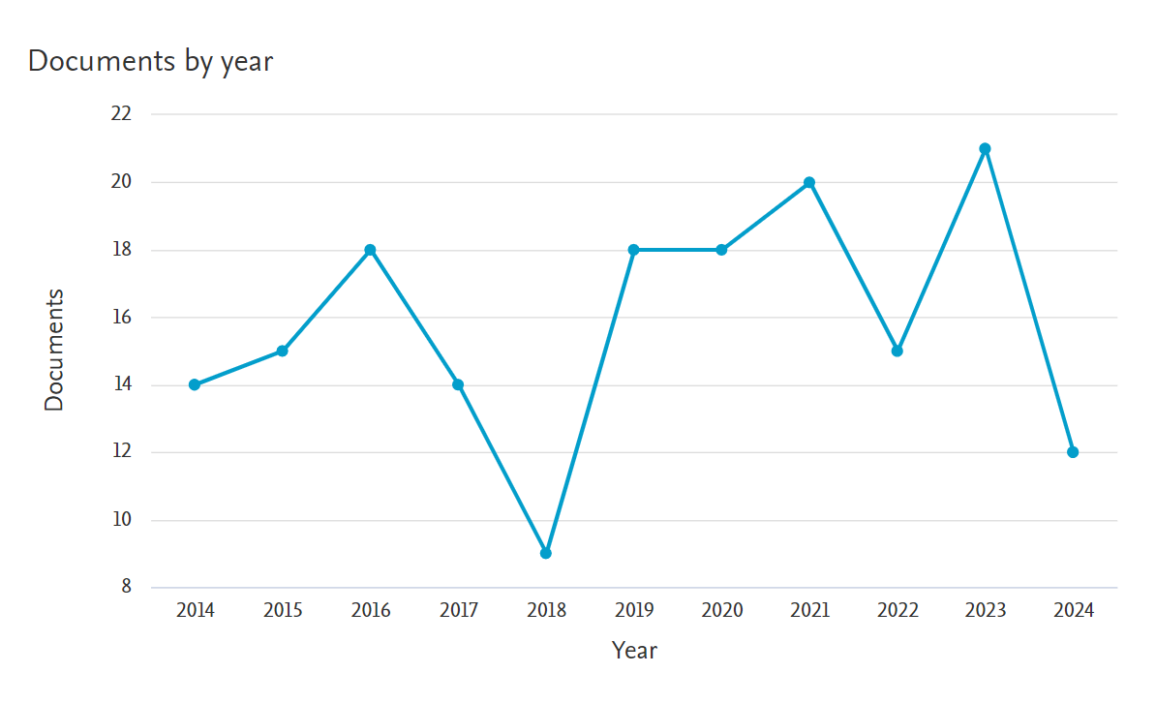
Figure 4 . Articles on bullying and counseling have been published.

These visualizations are invaluable for identifying clusters or hotspots, providing insight into the areas where a particular event is most widespread or significant. Figure 4 helps in identifying trends and patterns in data concentration by emphasizing data density. This presentation depicts a bibliometric mapping visualization display. In addition, Figure 4 illustrates the development of research trends from year to year, based on the data above, it is illustrated that research on bullying and counseling has increased significantly in 2021 and 2023. The above Griffith also provides information on the number of studies on bullying from 2014-2024 totaling 174 documents with details of 2024 12 articles, 2023 21 articles, 2022 15 articles, 2021 20 articles, 2020 18 articles, 2019 18 articles, 2018 9 articles, 2017 14 articles, 2016 18 articles, 2015 15 articles, 2014 14 articles. If calculated by the country for the keywords bullying and counseling, there are the top 10 countries that have publications on bullying and counseling. The countries are the United States 75 articles, the United Kingdom 20 articles, Australia 11 articles, Canada 9 articles, Indonesia 9 articles, China 8 articles, Germany 6 articles, South Korea 6 articles, Ghana 5 articles, and India 4 articles. The above details are depicted in the following diagram;
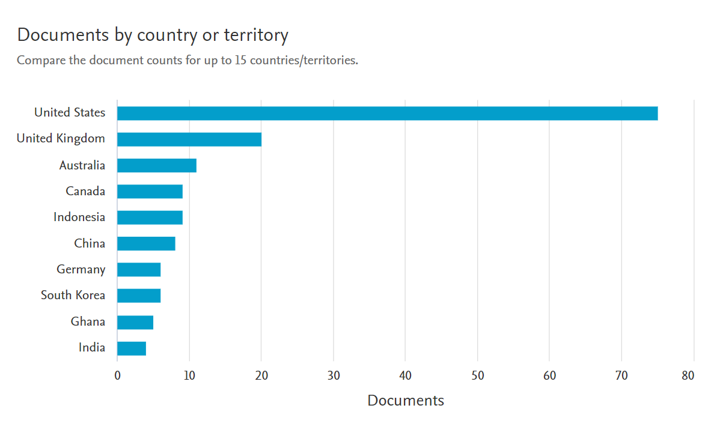
Gambar 5. Sepuluh negara wilayah teratas yang mengkaji bullying dalam konseling

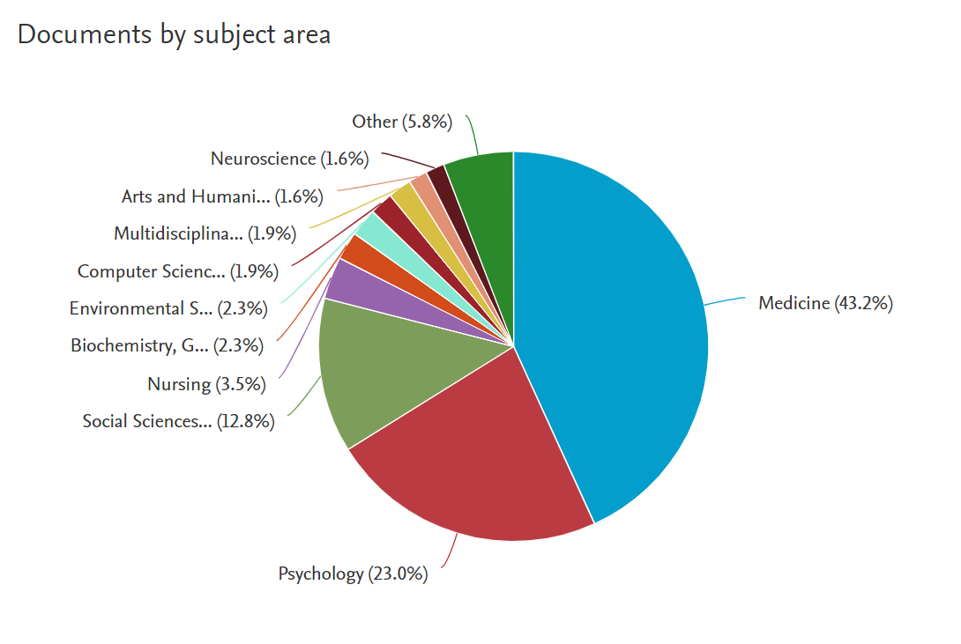
Figure 6. Visualization of subject areas from Scopus analysis

Based on Figure 6 above, the research on the most dominant bullying and counseling studies in the field of Medicine is 111 articles, Psychology is 59 articles, Social Sciences is 33 articles, Nursing is 9 articles, Biochemistry, Genetics, and Molecular Biology is 6 articles, Environmental Science is 6 articles, Computer Science is 5 articles, Multidisciplinary is 5 articles, Arts and Humanities is 4 articles and the field of study Neuroscience is 4 articles.
The study provides important insights into research trends on bullying in counseling over the past decade, with an analysis that included 174 articles published between 2014 and 2024. Through a bibliometric approach, several key findings were identified, including the most frequently discussed themes, patterns of collaboration between researchers, and the most influential journal and institutional contributions (Sánchez-Sánchez et al., 2024)
Identifying the themes and issues most frequently addressed in bullying and counseling research is one of the key findings of this analysis. The keywords that most frequently appear reflect the focus of research on the effects of bullying on mental health, counseling interventions, and the role of schools and social environments in addressing these issues. These findings are in line with previous research that emphasized the importance of understanding the psychological impact of bullying and the need for effective interventions in counseling (Cohen et al., 2023; Olié et al., 2023; Puspita & Herdiana, 2020)
The analysis also revealed a significant pattern of collaboration among researchers in this field. An extensive network of collaborations shows that bullying research in counseling often involves cross-disciplinary and cross-country cooperation. This is consistent with the literature showing that collaboration between researchers can improve the quality of research and broaden perspectives in related studies (Frank et al., 2024; Valido et al., 2022) In addition, the most prolific researchers in this field also appear to play a central role in the collaboration network, which shows influence in pushing research in a more comprehensive direction (Yosep et al., 2023).
The study also identified the journals and institutions that were most influential in publishing research related to bullying and counseling. Journals involved in the publication of articles related to bullying have a significant impact on disseminating new knowledge and findings in this field. The most influential institutions, especially those from countries with high levels of research, play an important role in the development of global knowledge about bullying and counseling interventions (Ayano et al., 2024; Pratiwi et al., 2024) These findings reflect the geographical distribution of research and the importance of access to academic resources in advancing studies in related sciences.
Bibliometric analysis of bullying research trends in counseling revealed an increase in researchers' interest in the effects of bullying on mental health, counseling interventions, and the role of schools and the social environment in overcoming this problem, but the increase in researchers' interest in current topics on the theme of bullying such as the theme of cyberbullying is still very limited and the model of anti-violence education in schools is also still a limited theme of study. Furthermore, this research also provides valuable insights into trends and dynamics in bullying research, which can be a guide for researchers and practitioners to direct their studies and interventions. Identification of key themes and collaboration patterns can help in designing further research and improving the effectiveness of counseling programs (Donthu et al., 2021).
The results of this study have important implications for counseling practice, education, and policy development. Counselors can use these findings to develop behavioral coping as a more specific intervention to improve the adversity of bullying victims. This finding also recommends a study on bullying from perpetrators, because this study is still very limited, perventive efforts on bullying and the study of themes about cyberbullying that are very relevant to the condition of the current generation are also very limited.
While this research provides valuable insights, there are some limitations that need to be noted. For example, this study only includes articles available in the Scopus database, thus allowing for other relevant research that is not included in the analysis. In addition, the bibliometric approach, although strong, has limitations in capturing nuances in the content of the research. Therefore, further research is recommended to incorporate qualitative methods to gain a deeper understanding of bullying and counseling trends.

CONCLUSION
Based on Bibliometric Analysis, it is shown that the main themes in bullying research in counseling include the psychological impact of bullying, the effectiveness of counseling interventions, and the role of the school and educational environment. An overview of cross-disciplinary and international collaborations that contribute to the advancement of research in this field. The most influential journals and dominant institutions in bullying research point to an important role in the development of knowledge and practice in this area. The limitations of this study are the limitation of data that only uses the Scopus database and the limitation in capturing the nuances of the research content. Further research is suggested to incorporate qualitative methods and expand the scope of the database to gain a more comprehensive understanding of bullying research trends in counseling. As such, the study contributes to a better understanding of trends and patterns in bullying and counseling research. It also provides a solid foundation for future research and interventions.

ACKNOWLEDGEMENT
We would like to express our sincere gratitude to all the lecturers, researchers, and colleagues who have shared valuable knowledge, insights, and advice during this research journey. Their guide has made a major contribution to the success of this research.

REFERENCES
Addy, N. D., Agbozo, F., Runge-Ranzinger, S., & Grys, P. (2021). Mental health difficulties, coping mechanisms and support systems among school-going adolescents in Ghana: A mixed-methods study. PLoS ONE, 16(4 April 2021). https://doi.org/10.1371/journal.pone.0250424
Aishwarya Gowda, A. G., Su, H. K., & Kuo, W. K. (2022). Monitoring Panic Situations in Students and Alerting Using Artificial Intelligence. Sensors and Materials, 34(9), 3503–3512. https://doi.org/10.18494/SAM3927
Aria, M., & Cuccurullo, C. (2017). bibliometrix: An R-tool for comprehensive science mapping analysis. Journal of Informetrics, 11(4), 959–975.
Ayano, G., Rooney, R., Pollard, C. M., Dantas, J. A. R., Lobo, R., Jeemi, Z., Burns, S., Cunningham, R., Monterosso, S., Millar, L., Hassan, S., Dovchin, S., Oliver, R., Coleman, K., & Alati, R. (2024). Risk and protective factors of youth crime: An umbrella review of systematic reviews and meta-analyses. Clinical Psychology Review, 113. https://doi.org/10.1016/j.cpr.2024.102479
Burnham, J. F. (2006). Scopus database: a review. Biomedical Digital Libraries, 3, 1–8.
Cohen, A., Bendelow, A., Smith, T., Cicchetti, C., Davis, M. M., & Heffernan, M. (2023). Parental Attitudes on Social Media Monitoring for Youth: Cross-Sectional Survey Study. JMIR Pediatrics and Parenting, 6(1). https://doi.org/10.2196/46365
Donthu, N., Kumar, S., Mukherjee, D., Pandey, N., & Lim, W. M. (2021). How to conduct a bibliometric analysis: An overview and guidelines. Journal of Business Research, 133, 285–296.
Efianingrum, A., Dwiningrum, S. I. A., & Nurhayati, R. (2021). Cyberbullying high school students on social media: Prevalence and recommendations. Journal of Educational Development: Foundations and Applications, 8(1), 144–153. https://doi.org/10.21831/jppfa.v8i2.38300
Frank, M., Daniel, L., Hays, C. N., Shanahan, M. E., Naumann, R. B., McNaughton Reyes, H. L., & Austin, A. E. (2024). Association of Food Insecurity With Multiple Forms of Interpersonal and Self-Directed Violence: A Systematic Review. Trauma, Violence, and Abuse, 25(1), 828–845. https://doi.org/10.1177/15248380231165689
Li, C., Wang, P., Martin-Moratinos, M., Bella-Fernández, M., & Blasco-Fontecilla, H. (2022). Traditional bullying and cyberbullying in the digital age and its associated mental health problems in children and adolescents: a meta-analysis. European Child and Adolescent Psychiatry, 33(9), 2895 – 2909. https://doi.org/10.1007/s00787-022-02128-x
Marcos, V., Montes, Á., Cea, B., & Seijo, D. (2024). Prevalence and quantifying the effects of bullying victimization in school-aged children in internalizing and externalizing mental health problems and academic failure. Revista de Psicologia Clinica Con Ninos y Adolescentes, 11(2), 66–72. https://doi.org/10.21134/rpcna.2024.11.2.8
Merrin, G. J., Wang, J. H., Kiefer, S. M., Jackson, J. L., Pascarella, L. A., Huckaby, P. L., Blake, C. L., Gomez, M. D., & Smith, N. D. W. (2024). Adverse Childhood Experiences and Bullying During Adolescence: A Systematic Literature Review of Two Decades. Adolescent Research Review, 9(3), 513–541. https://doi.org/10.1007/s40894-023-00229-5
Muhammad, I., & Triansyah, F. A. (2023). A complete guide to bibliometric analysis with VOSviewer: Understanding research developments and trends in the digital age. https://www.google.co.id/books
Olié, L., Maternowska, M. C., & Fry, D. (2023). Addressing violence against children: A systematic review on interventions to accelerate the achievement of the UN sustainable development goal in Europe and Africa. Child Abuse and Neglect, 145. https://doi.org/10.1016/j.chiabu.2023.106427
Pradana, C. D. E. (2024). Pengertian Tindakan Bullying, Penyebab, Efek, Pencegahan dan Solusi. Jurnal Syntax Admiration, 5(3), 884–898. https://doi.org/10.46799/jsa.v5i3.1071
Pratiwi, H., Islamy, M. I., & Riwanda, A. (2024). Fostering Safe Schools: Empowering Educators and Parents in the Fight Against Violence in Early Childhood Education Setting. Participatory Educational Research, 11(4), 140–159. https://doi.org/10.17275/per.24.53.11.4
Puspita, S. A. L., & Herdiana, I. (2020). Action Research on Early Childhood and Kindergarten Teachers: Increasing Educators' Knowledge about Bullying in Schools through Psychoeducational Activities. Udayana Journal of Psychology, 7(2), 1. https://doi.org/10.24843/jpu.2020.v07.i02.p01
Ratnasari, A., & Dwisusanto, Y. B. (2024). Bibliometric Mapping of the Development of Biophilic Research in Indonesia. FLOW: Journal of Architecture, 7(1), 1–11.
Sainz, V., Soto-García, O., Calmaestra, J., & Maldonado, A. (2023). Impact of the TEI Peer Tutoring Program on Coexistence, Bullying and Cyberbullying in Spanish Schools. International Journal of Environmental Research and Public Health, 20(19). https://doi.org/10.3390/ijerph20196818
Sánchez-Sánchez, A. M., Ruiz-Muñoz, D., & Sánchez-Sánchez, F. J. (2024). Research trends in the bias-based aggression among youth. Children and Youth Services Review, 158. https://doi.org/10.1016/j.childyouth.2024.107444
Smith, P. K. (2014). Understanding school bullying: Its nature and prevention strategies.
Swit, C. S., Blakely-McClure, S. J., & Kamper-DeMarco, K. K. E. (2023). Preventing Bullying in Preschool-Age Children: Predictors of Defending Behaviour. International Journal of Bullying Prevention, 5(3), 202–216. https://doi.org/10.1007/s42380-023-00166-w
Thornton, E., Panayiotou, M., & Humphrey, N. (2024). Prevalence, Inequalities, and Impact of Bullying in Adolescence: Insights from the #BeeWell Study. International Journal of Bullying Prevention. https://doi.org/10.1007/s42380-024-00244-7
Valido, A., Rivas-Koehl, M., Rivas-Koehl, D., Espelage, D. L., Lawrence, T. I., & Robinson, L. E. (2022). Latent Class Analysis of Victimization Patterns and Associated Protective Factors among LGBTQ Youth. International Journal of Environmental Research and Public Health, 19(16). https://doi.org/10.3390/ijerph19169953
Van Eck, N., & Waltman, L. (2010). Software survey: VOSviewer, a computer program for bibliometric mapping. Scientometrics, 84(2), 523–538.
Van Raan, A. F. (2014). Advances in bibliometric analysis: research performance assessment and science mapping. Bibliometrics Use and Abuse in the Review of Research Performance, 87(4), 17–28.
Xu, X., Li, Y., Liu, S., & Wang, W. (2024). Longitudinal Relationships Between Bullying Victimization and Dual Social Behaviors: The Roles of Self-Compassion and Trauma-Related Shame. Psychology Research and Behavior Management, 17, 1463–1475. https://doi.org/10.2147/PRBM.S450013
Yosep, I., Hikmat, R., Mardhiyah, A., Kurniawan, K., & Amira, I. (2023). A Scoping Review of the Online Interventions by Nurses for Reducing Negative Impact of Bullying on Students. Journal of Multidisciplinary Healthcare, 16, 773–783. https://doi.org/10.2147/JMDH.S406050
Zakiyyah, F. N., Winoto, Y., & Rohanda, R. (2022). Bibliometric mapping of information architecture research development on Google Scholar using VOSviewer. Information: Journal of Library and Information Science, 2(1), 43. https://doi.org/10.24198/inf.v2i1.37766
Zupic, I., & Čater, T. (2015). Bibliometric methods in management and organization. Organizational Research Methods, 18(3), 429–472.

