 | 
DAFTAR HADIR PERKULIAHAN SEMESTER GENAP
TAHUN AKADEMIK 2019/2020
 |  | MATA KULIAH : EVALUASI PEMBELAJARAN |  |  |  |  |  | SKS : 3 |  | SEMESTER / KELAS / RUANG : 4 / B / GKB.Lt.2-13
 |  | NO | NIM |  |  | NAMA MAHASISWA/I |  |  |  | 1 | 2 | 3 | 4 | 5 | 6 | 7 | 8 |  | 9 |  | 10 | 11 | 12 | 13 | 14 | 15 | 16
 |  | 1 | 1811290033 |  |  | MIFTAHUL JANNAH |  |  |  | M | M | M | M | M | M | M | M |  | M |  | M | M | M | M | M | M | M
 |  | 2 | 1811290034 |  |  | NOVINDINA AYUTIANI |  |  |  | M | M | M | M | M | M | M | M |  | M |  | M | M | M | M | M | M | M
 |  | 3 | 1811290035 |  |  | LIZENTIYA |  |  |  | M | M | M | M | M | M | M | M |  | M |  | M | M | M | M | M | M | M
 |  | 4 | 1811290036 |  |  | LIA NOVITASARI |  |  |  | M | M | M | M | M | M | M | M |  | M |  | M | M | M | M | M | M | M
 |  | 5 | 1811290037 |  |  | ASEP PIRMAN |  |  |  | M | M | M | M | M | M | M | M |  | M |  | M | M | M | M | M | M | M
 |  | 6 | 1811290039 |  |  | DWI RAHMA DESITA |  |  |  | M | - | - | M | M | M | M | M |  | M |  | M | M | M | M | M | M | M
 |  | 7 | 1811290040 |  |  | REWI NENCI |  |  |  | M | M | M | M | M | M | M | M |  | M |  | M | M | M | M | M | M | M
 |  | 8 | 1811290041 |  |  | PEBI AGSIR |  |  |  | M | M | I | M | M | M | M | M |  | M |  | M | M | M | M | M | M | M
 |  | 9 | 1811290042 |  |  | DINDA PUTRI AGUSTINA |  |  |  | M | M | M | M | M | M | M | M |  | M |  | M | M | M | M | M | M | M
 |  | 10 | 1811290043 |  |  | WIDIA LESTARI |  |  |  | M | M | M | M | M | M | M | M |  | M |  | M | M | M | M | M | M | M
 |  | 11 | 1811290046 |  |  | INTAN PERMATA SARI |  |  |  | M | M | M | M | M | M | M | M |  | M |  | M | M | M | M | M | M | M
 |  | 12 | 1811290047 |  |  | DEKA GUSTI SULASTRI |  |  |  | M | M | M | M | M | M | M | M |  | M |  | M | M | M | M | M | M | M
 |  | 13 | 1811290048 |  |  | DELMIKE SRI MULYANI |  |  |  | M | - | - | M | M | M | M | M |  | M |  | M | M | M | M | M | M | M
 |  | 14 | 1811290049 |  |  | YULITA PURNAMA SARI |  |  |  | M | M | M | M | M | M | M | M |  | M |  | M | M | M | M | M | M | M
 |  | 15 | 1811290050 |  |  | ASWIN SUNADI |  |  |  | M | M | M | M | M | M | M | M |  | M |  | M | M | M | M | M | M | M
 |  | 16 | 1811290051 |  |  | DELA LARASATI |  |  |  | M | M | M | M | M | M | M | M |  | M |  | M | M | M | M | M | M | M
 |  | 17 | 1811290052 |  |  | HERI EFRIYADI |  |  |  | M | M | M | M | M | M | M | M |  | M |  | M | M | M | M | M | M | M
 |  | 18 | 1811290053 |  |  | CICI SILI PUTRI |  |  |  | M | M | M | M | M | M | M | M |  | M |  | M | M | M | M | M | M | M
 |  | 19 | 1811290054 |  |  | EGO AZISMI PUTRA |  |  |  | M | M | M | M | M | M | M | M |  | M |  | M | M | M | M | M | M | M
 |  | 20 | 1811290057 |  |  | AYU WULANDARI |  |  |  | M | M | M | M | M | M | M | M |  | M |  | M | M | M | M | M | M | M
 |  | Waktu Dicetak : |  |  | Minggu, 12 Juli 2020 12:35:04
 |  | MATA KULIAH : EVALUASI PEMBELAJARAN |  |  |  |  |  | SKS : 3 |  | SEMESTER / KELAS / RUANG : 4 / B / GKB.Lt.2-13
 |  | NO | NIM |  |  | NAMA MAHASISWA/I |  |  |  | 1 | 2 | 3 | 4 | 5 | 6 | 7 | 8 |  | 9 |  | 10 | 11 | 12 | 13 | 14 | 15 | 16
 |  | 21 | 1811290058 |  |  | ERLIANA |  |  |  | M | M | M | M | M | M | M | M |  | M |  | M | M | M | M | M | M | M
 |  | 22 | 1811290059 |  |  | GILANG KURNIAWAN |  |  |  | M | M | M | M | M | M | M | M |  | M |  | M | M | M | M | M | M | M
 |  | 23 | 1811290060 |  |  | BELA LIPINIA |  |  |  | M | M | M | M | M | M | M | M |  | M |  | M | M | M | M | M | M | M
 |  | 24 | 1811290061 |  |  | LEO ALKA |  |  |  | M | M | M | M | M | M | M | M |  | M |  | M | M | M | M | M | M | M
 |  | 25 | 1811290062 |  |  | LUCI ANIKA |  |  |  | M | M | M | M | M | M | M | M |  | M |  | M | M | M | M | M | M | M
 |  | 26 | 1811290064 |  |  | BARHUM SETIAWAN KURNIAWAN |  |  |  | M | M | M | M | M | M | M | M |  | M |  | M | M | M | M | M | M | M
 |  | 27 | 1811290065 |  |  | SINTA DAMAI YANTI |  |  |  | M | M | M | M | M | M | M | M |  | M |  | M | M | M | M | M | M | M
 |  | 28 | 1811290066 |  |  | NADIA OKTARIYANI |  |  |  | M | M | M | M | M | M | M | M |  | M |  | M | M | M | M | M | M | M
 |  | 29 | 1811290081 |  |  | PEBRIYANSYA |  |  |  | M | M | M | M | M | M | M | M |  | M |  | M | M | M | M | M | M | M
 |  | 30 | Dosen Utama |  |  | DRS. SUKARNO, M.PD |  |  |  | M | M | M | M | M | M | M | M |  | M |  | M | M | M | M | M | M | M
BENGKULU, 12 Juli 2020
Ka. Prodi
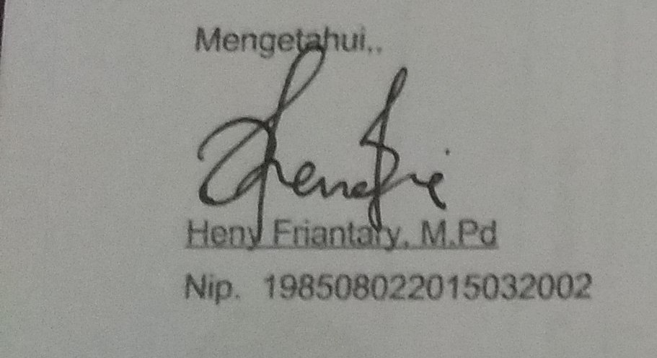
 |  |  |  |  |  |  |  |  |  |  |  |  |  |  |  |  |  |  |  | Heny Friantary, M.Pd
 |  | Waktu Dicetak : |  |  | Minggu, 12 Juli 2020 12:35:04

